OS Assignment - 4

Name – Ayush Mondal
Enroll No. - 2011200001017
Dept – CSE (Section – A, Group – 1)

1) Write a shell script to take two numbers as range from the terminal and print non-prime numbers between the given range.

Code
echo -n "Enter lower bound: "
read lb
echo -n "Enter upper bound: "
read ub
echo "All the non-prime mumbers are..."
for (( i = lb; i <= ub; i++ ))
do
for (( j = 2; j*j <= i; j++ ))
do
if [ `expr $i % $j` -eq 0 ]
then
echo -n $i" "
break
fi
done
done
echo " "

Output
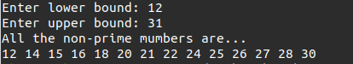

2) Write a shell script to take n numbers of elements in an array amd print the third largest number. Value of n must be taken from the terminal.

Code
for (( i=0; i < $1; i++ ))
do
echo -n "Enter a value: "
read arr[$i]
done
for (( i=1; i < $1; i++ ))
do
for (( j=0; j < $1-i; j++ ))
do
if [ ${arr[$j]} -gt ${arr[`expr $j + 1`]} ]
then
t=${arr[$j]}
arr[$j]=${arr[`expr $j + 1`]}
arr[`expr $j + 1`]=$t
fi
done
done
echo "The third largest value is:" ${arr[`expr $1 - 3`]}

Output

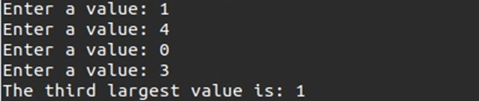

3) Store n number of elements in an array and find out sum of the array elements. Value of n must be taken from the terminal.

Code
sum=0
for (( i=0; i < $1; i++ ))
do
echo -n "Enter a value: "
read arr[$i]
sum=`expr $sum + ${arr[$i]}`
done
echo "The sum of all elements is:" $sum

Output
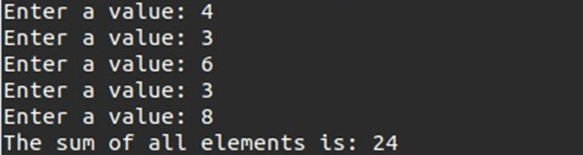

4) Write a shell program that will accept 10 numbers from the terminal and will search the position of a given number in the supplied number.
Code
echo -n "Enter the number to be searched: "
read n
c=1
for i in $*
do
if [ $i -eq $n ]
then
echo "The position of" $n "is" $c
break
fi
c=`expr $c + 1`
done
Output

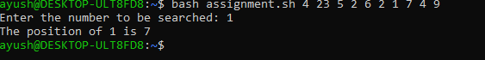

5) Write a shell program to sort a list of n numbers. Value of n must be taken from the terminal.
Code
for (( i=0; i < $1; i++ ))
do
echo -n "Enter a value: "
read arr[$i]
done
for (( i=1; i < $1; i++ ))
do
for (( j=0; j < $1-i; j++ ))
do
if [ ${arr[$j]} -gt ${arr[`expr $j + 1`]} ]
then
t=${arr[$j]}
arr[$j]=${arr[`expr $j + 1`]}
arr[`expr $j + 1`]=$t
fi
done
done
for (( i=0; i < $1; i++ ))
do
echo -n ${arr[$i]}" "
done
echo " "
Output

